Activity 8.5 – Analyze a Lesson
Apply your Knowledge
Workbook

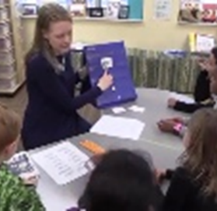
Context: 1st grade small group
- Students are decoding words in isolation and in text
- Students are using letter cards and pocket cards

- When do you see evidence of guided or independent practice? Record specific times below.
Time | Observation
- Does this lesson meet our criteria for guided practice?
The methods used to provide guided practice should:
- Lead students in steps toward learning outcome
- Procedural task: execute each step separately
- Knowledge task: address each unit (e.g. vocabulary word) one at a time
Explanation:

- Provide appropriate prompts
- Design a variety of prompt types linked to task and likely student need
- Change level of prompting in response to student’s progress
Explanation:

- Observe and provide immediate feedback
- Watch students carefully
- Interpret the meaning of errors
- Provide feedback that aligns with the type of error
Explanation:

